Java Byte Code is Platform Independent

You can run in any platform windows, MAC, Linux with JAVA Virtual Machine (JVM)

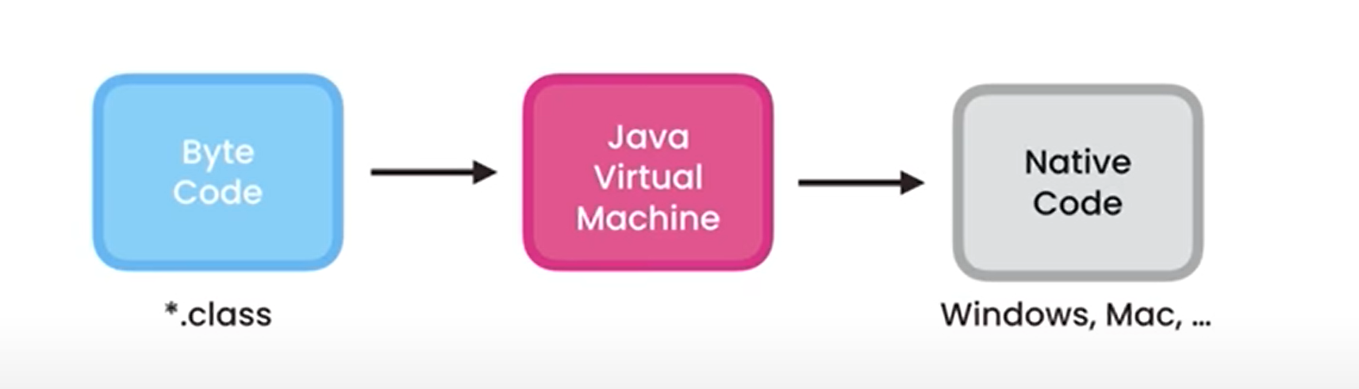

Converts the java byte code in to native code that windows understand ,becos of this architecture, java is platform independent , write a code in windows and execute in linux and mac

When u run in the program in other platform

Java com.codewithanu.Main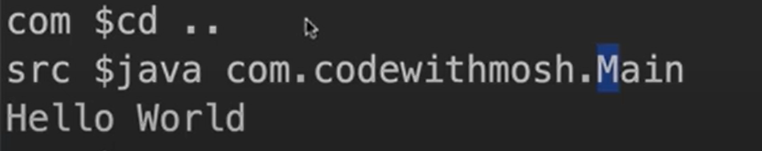

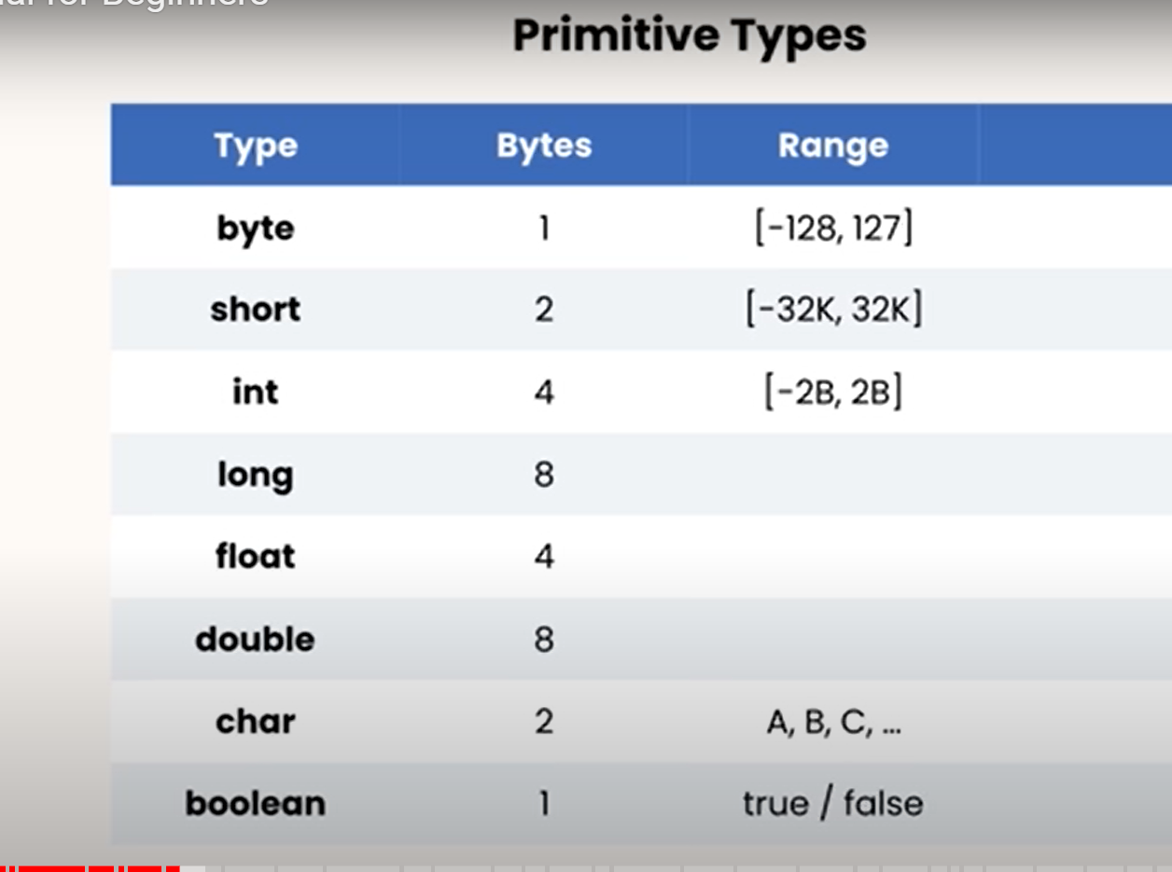

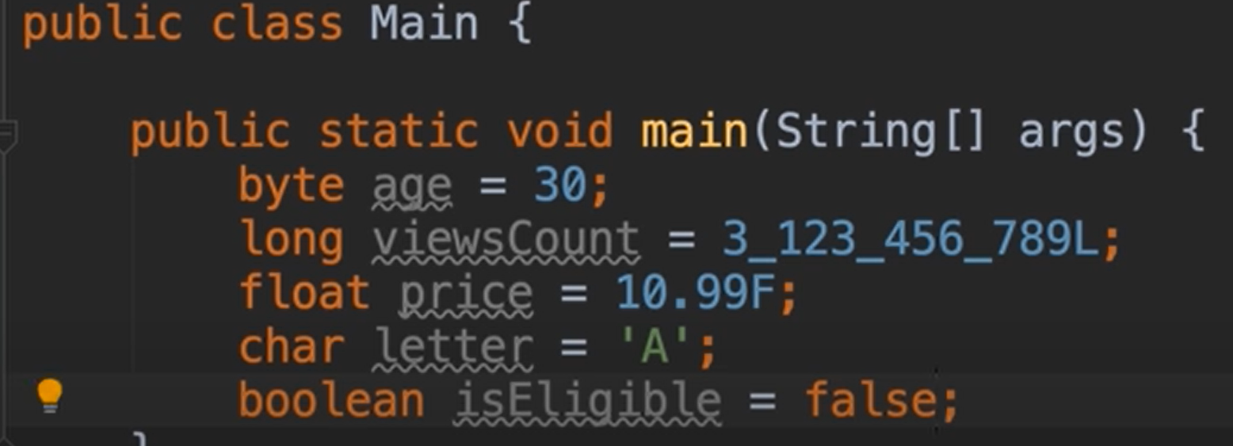

**Primitive types are storing simple values and Reference types are complex values**

**Reference:**

Date Class – Same class from different packages

Packages create namespace for our classes

Reference types copy the references and primitive types copy the values

Byte x=1

Byte y =x

X=2

Print(y)

Out:1

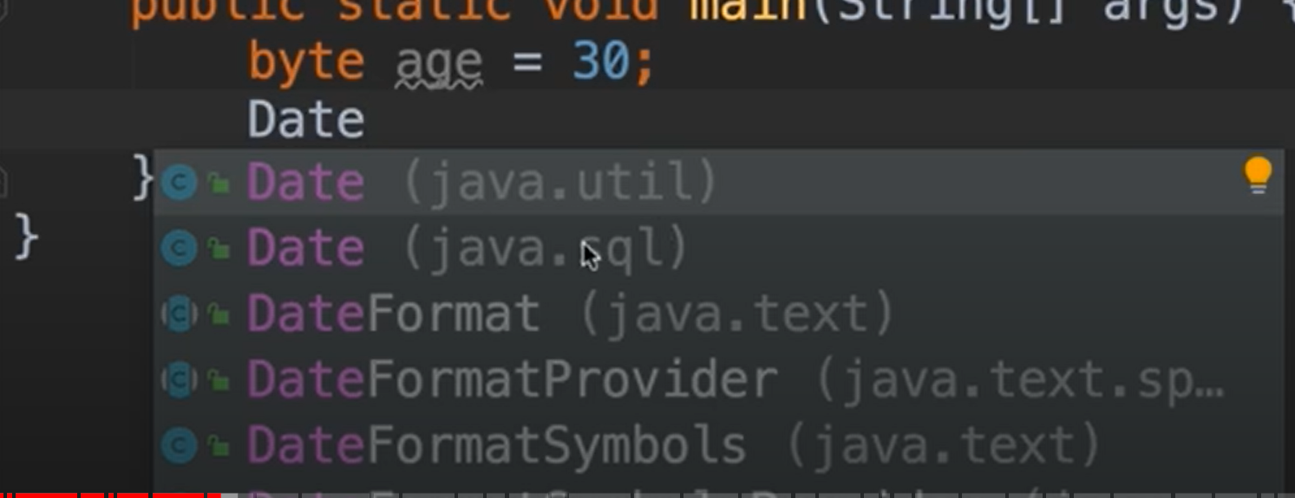

Primitive type don’t need to allocate memory -memory is allocated and released by Java run time environment (JVM)

Eg : byte age = 30

Reference types need to allocate memory

Eg: Date now = new Date();

The variable new is the instance of the Date class. Date() is the template or blueprints for creating objects. Objects are the instance of the class.

Instances have members, we can access using the .operator (Primitive types don’t have members)

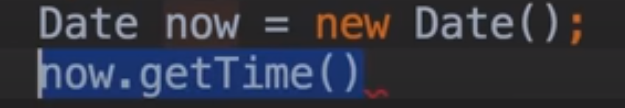

Sou then tab 🡪 you will get System.out.println();

Primitive Vs Reference

Reference types copy the references and primitive types copy the values

Primitive types

Byte x=1

Byte y =x

X=2

Print(y)

Out:1

Reference Types:

Point Class

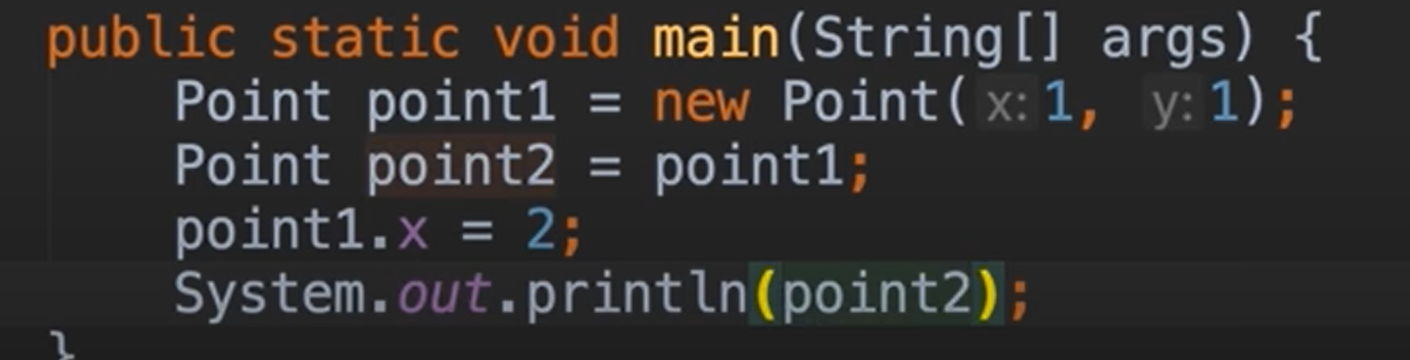

Out: 2

Point1 and point2 are referencing the same object.

STRINGS

Strings are immutatble

**Escape Sequence \**

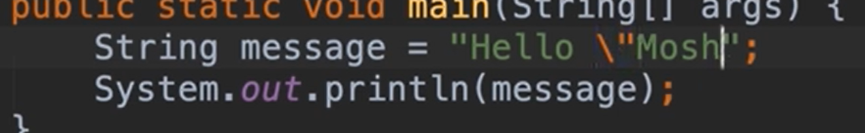

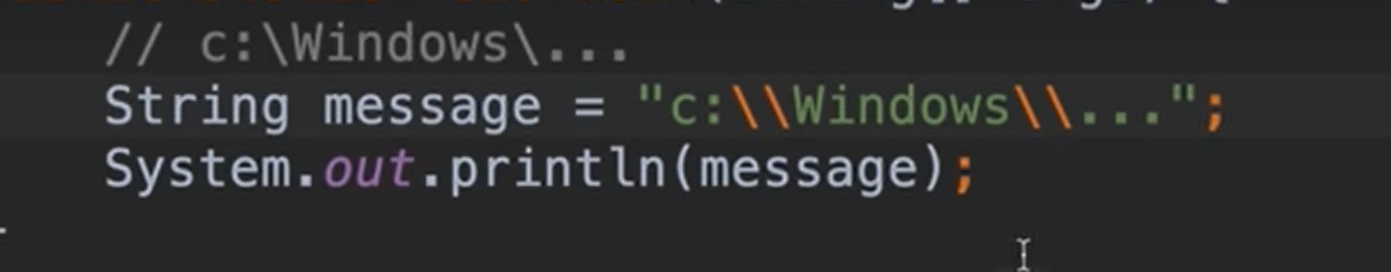 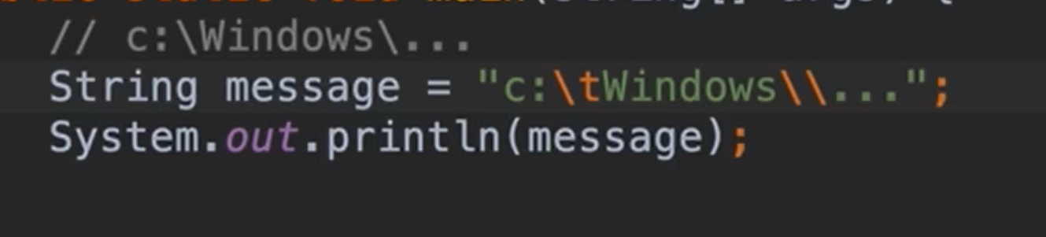

Arrays:

int[] numbers = new int[5]

numbers[0] = 1

numbers[1] = 2

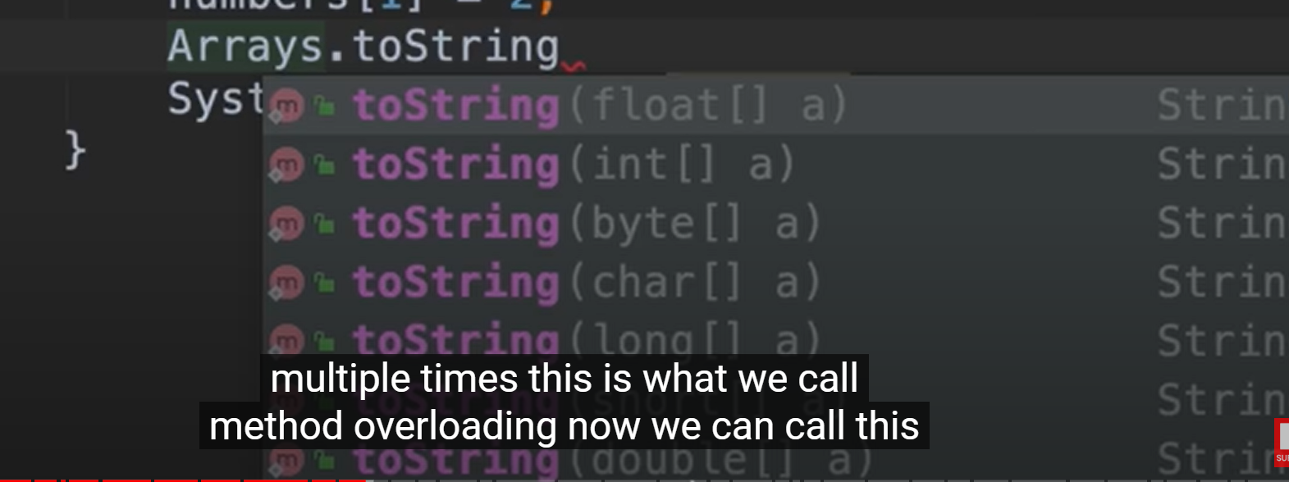

toString. This method is implemented multiple times. This is called method overloading..

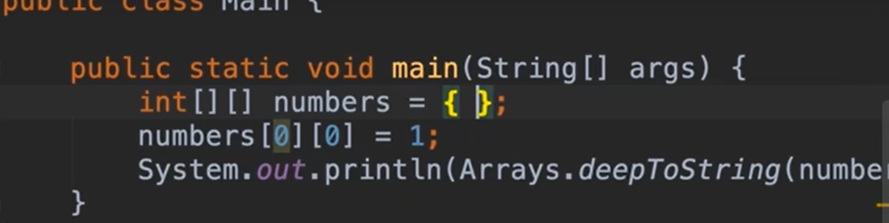

Multidimensional arrays – Arrays.deepToString()

Constants:

Do not change the variable – use **final**



Java compiler consider this as constant , we cannot change this variable value later on

**Arithmetic Expressions**

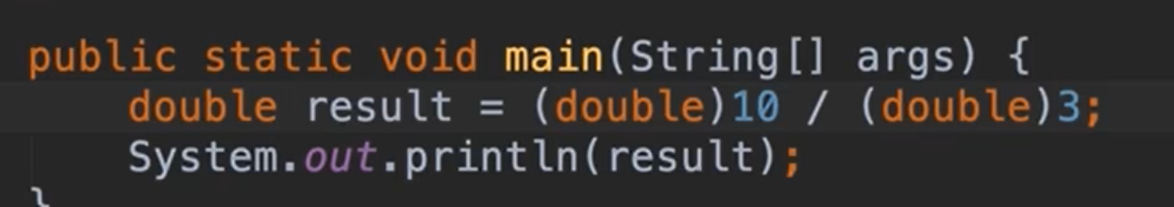

**Augmented assignement operator**

**X += 2**

**Order of Operations:**

**()**

**\*/**

**+-**

**Implicit Casting:**

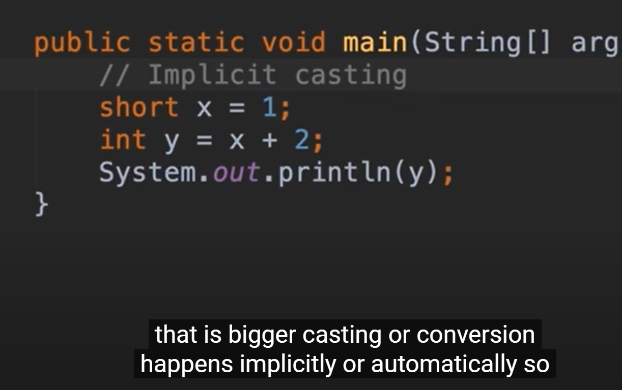

Datatype with bigger casting, automatic conversion happens implicitly

Integer is less precise than double

Java automatically cast the int into double

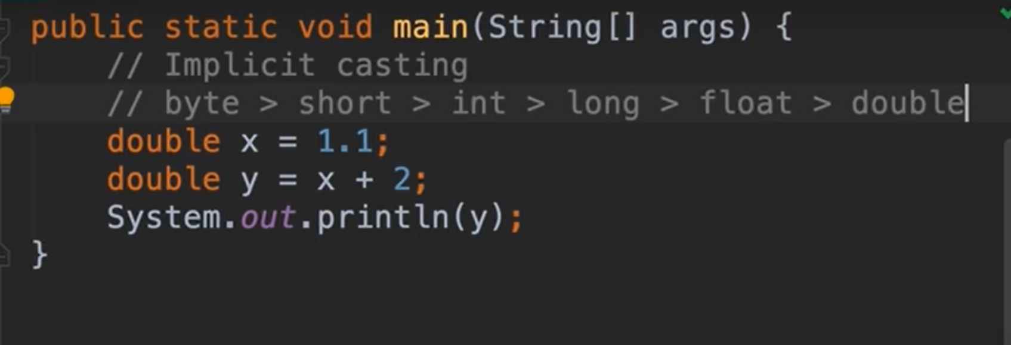

Out:3.2

Explicit casting

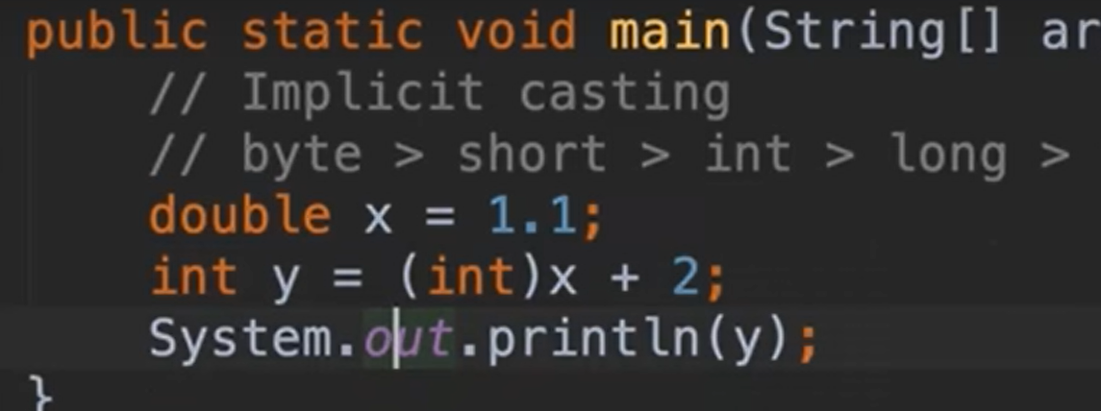

Out: 2

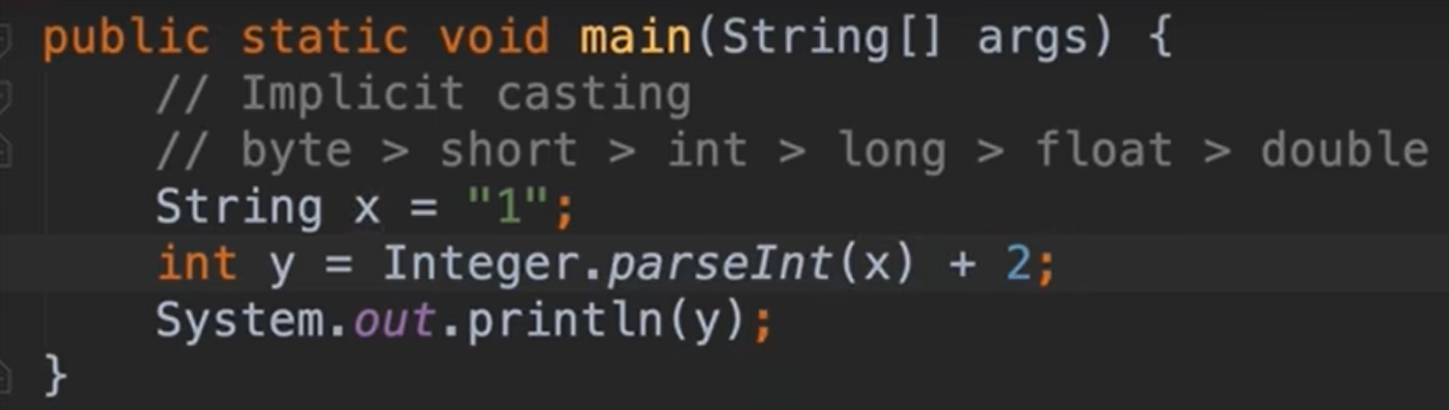

Math

Math.floor.

Math.ceil

Math.round()

Math.min

Math.random

**Number Format:**

**NumberFormat(java.text)**

**‘NumberFormat’ is abstract; cannot be instantiated**

**NumberFormat number = new NumberFormat()**



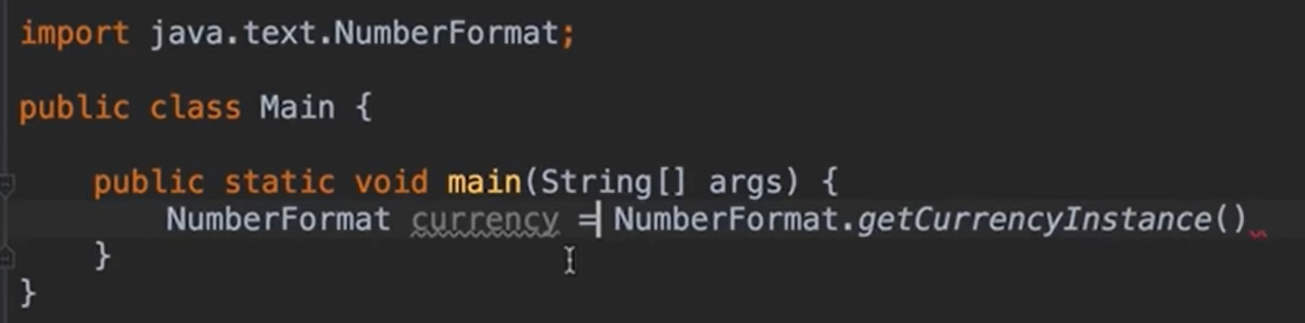

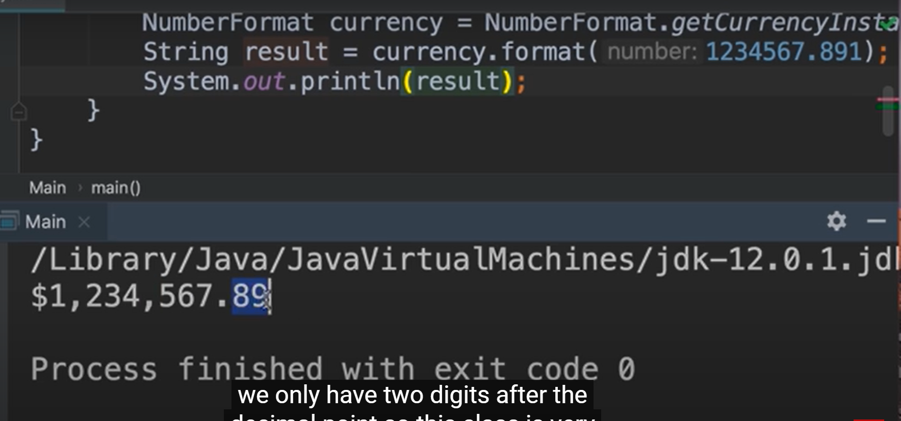

**getPercentInstance**

# Reading Input:

Scanner (java.util)

System.in/System.out

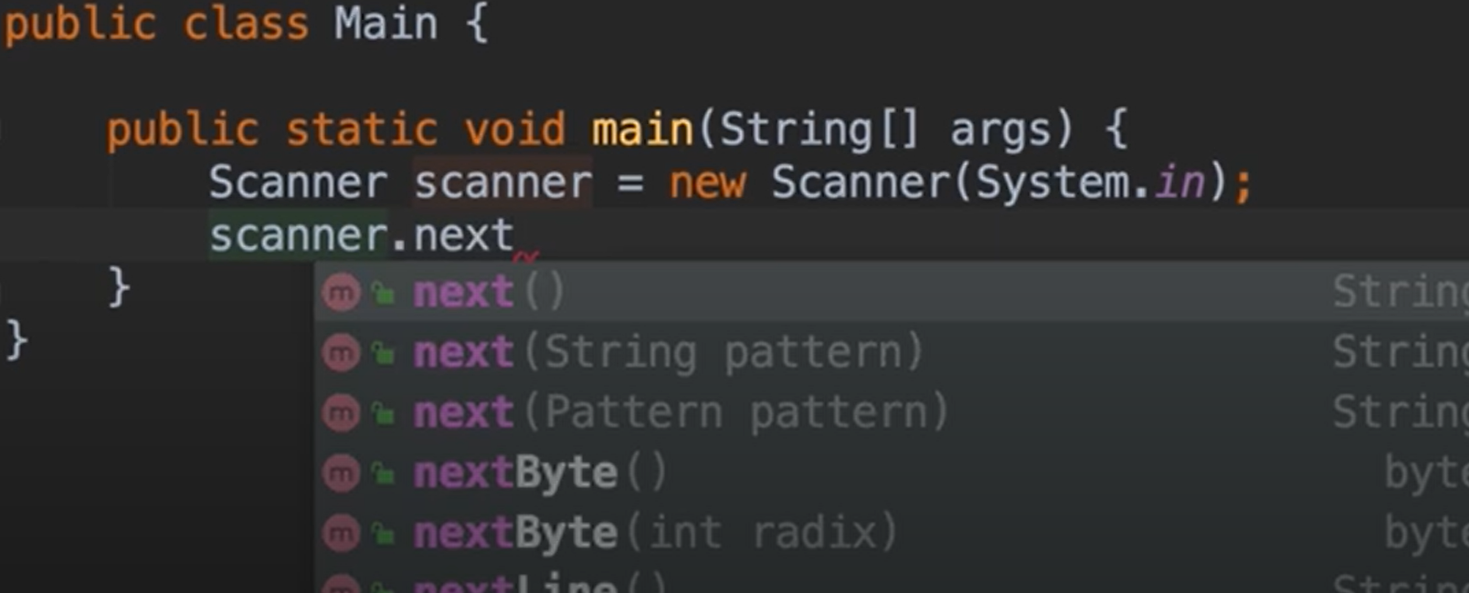

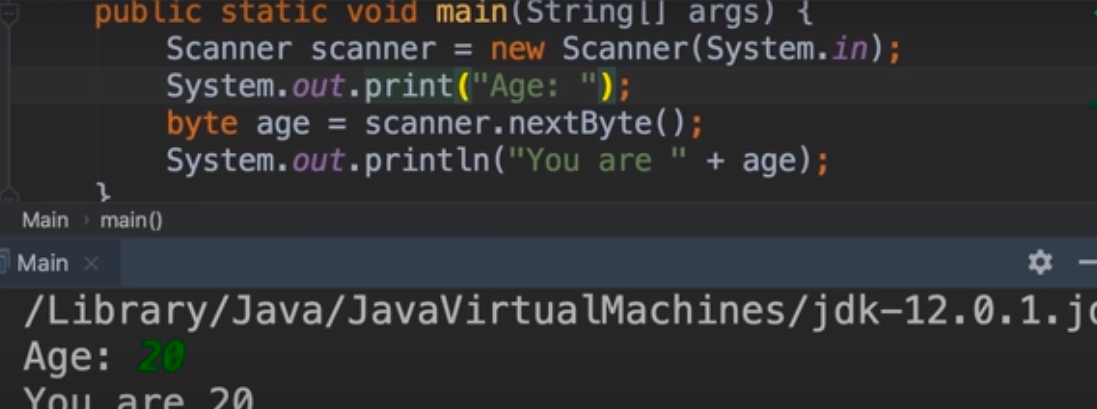

Println – enter new line

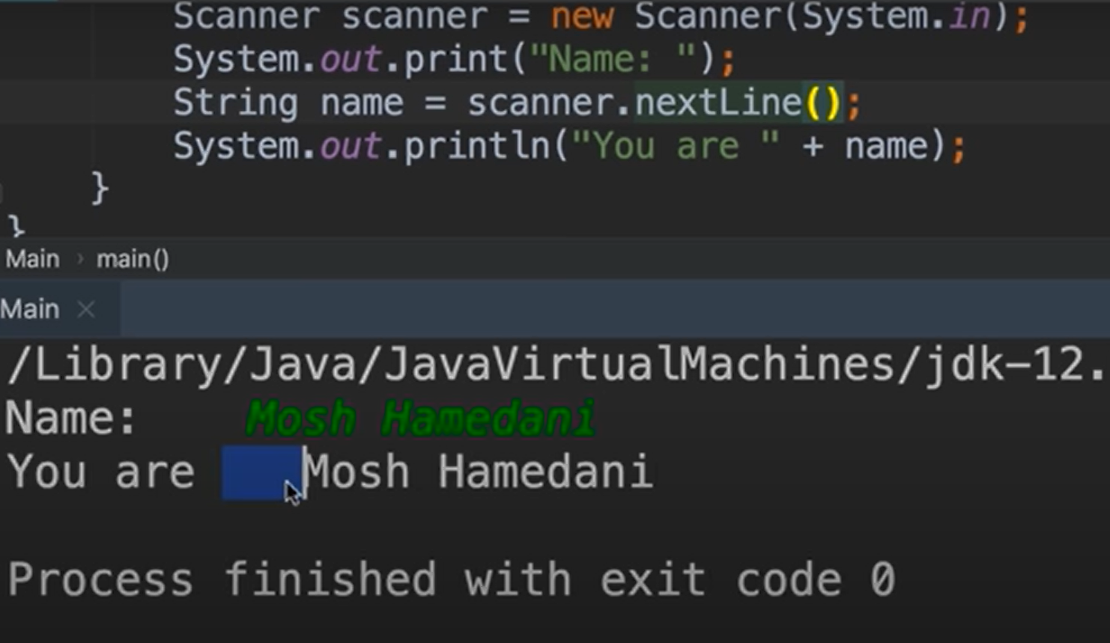

Scanner.Next – just take the first word only. It won’t take the word after the space.

Scanner.NextLine.trim()

If

If else

Switch statement

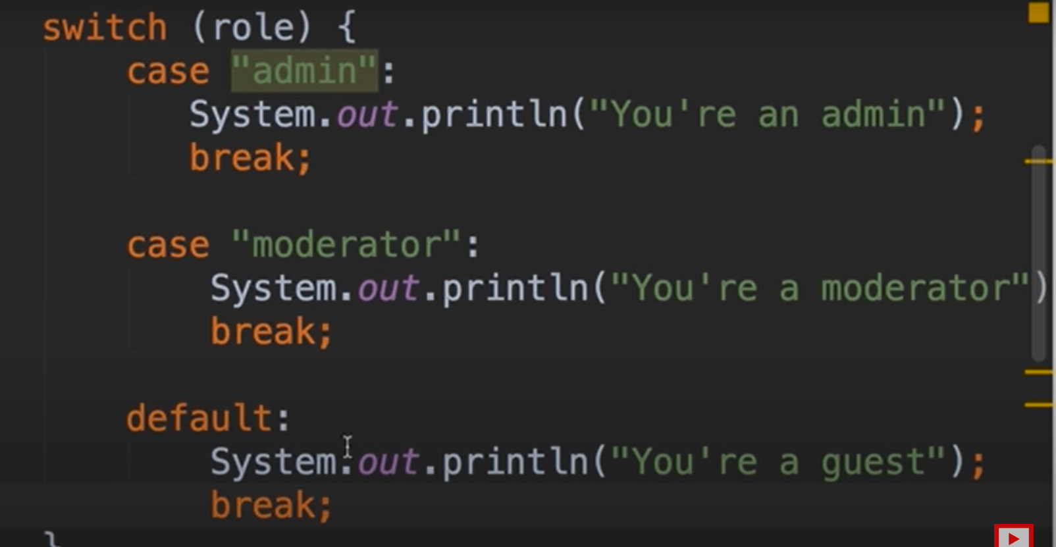

# JAVA 8 Feature

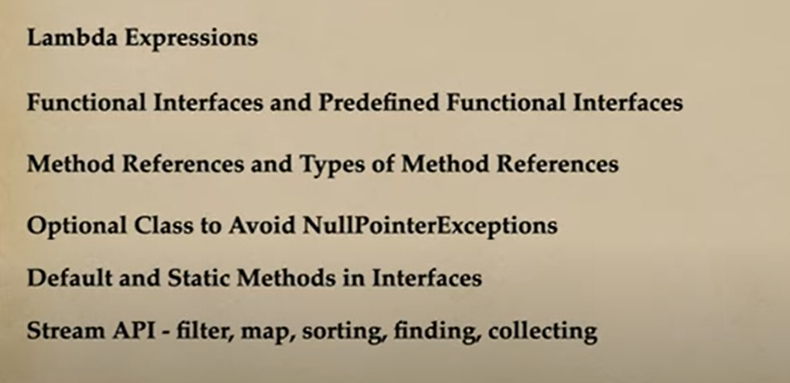

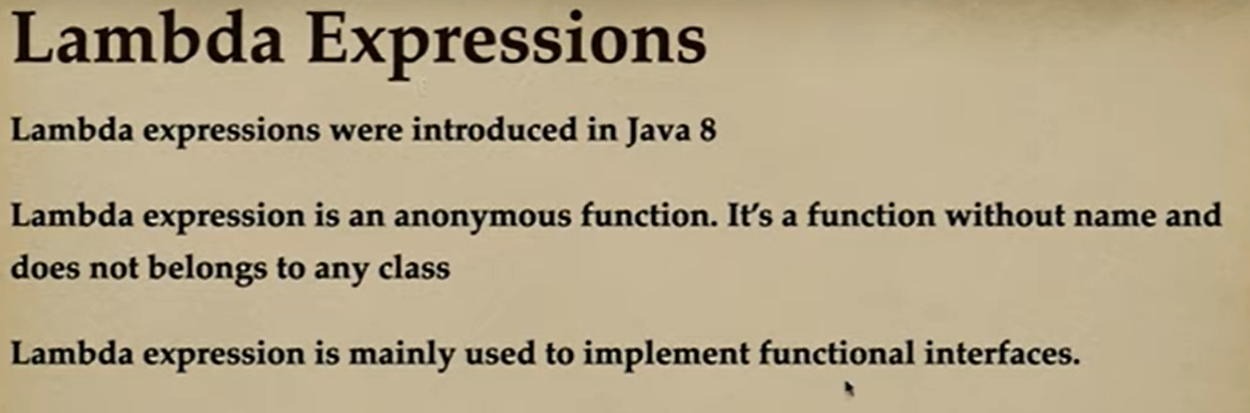

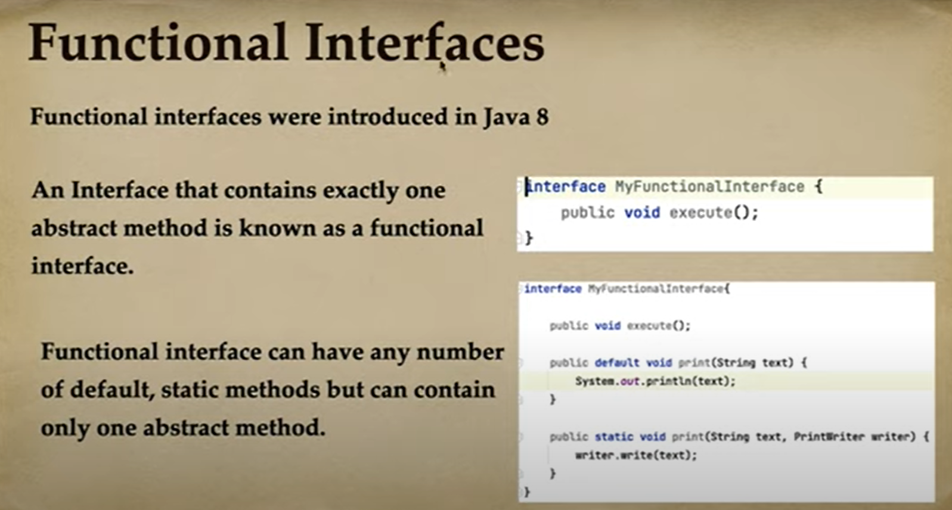

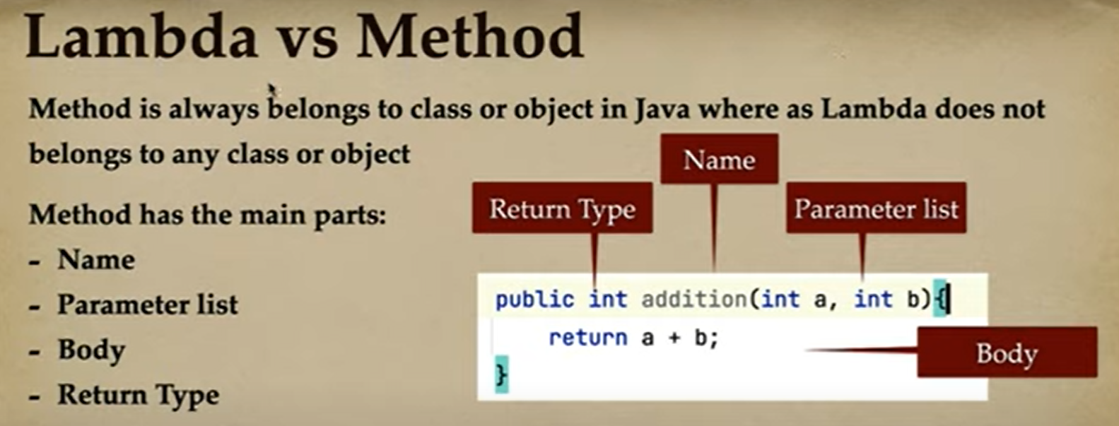

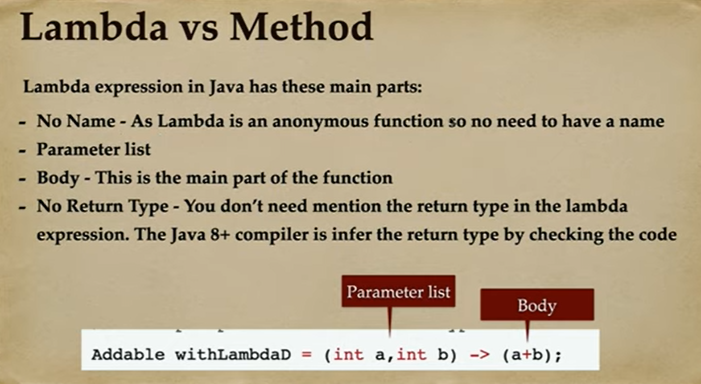

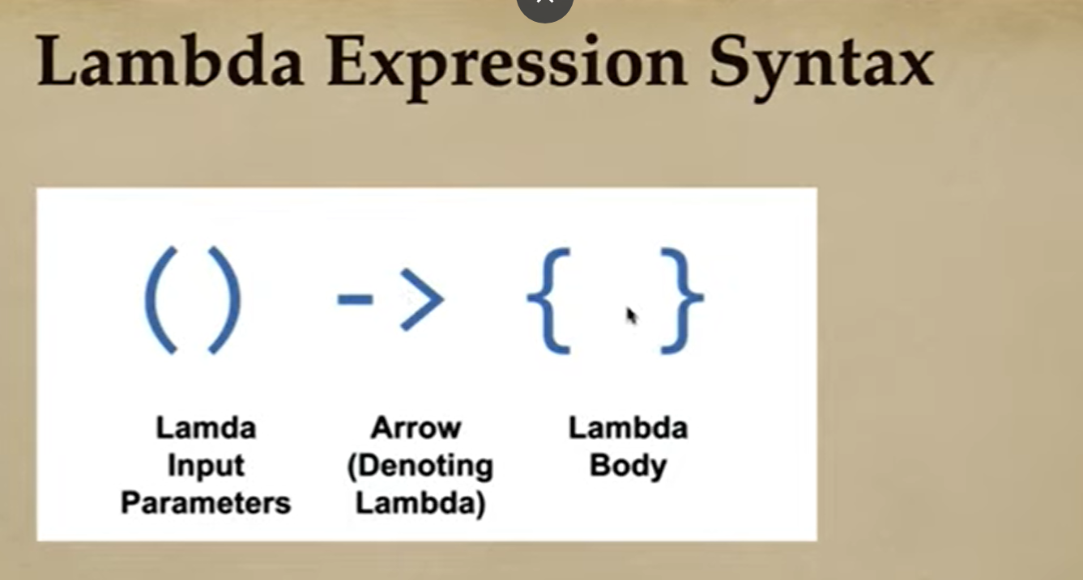

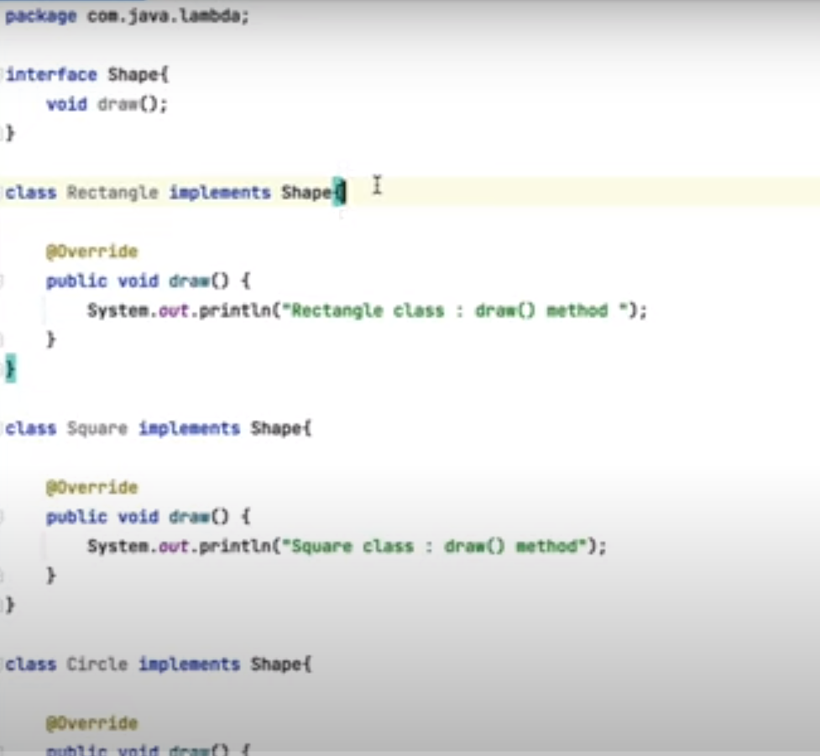

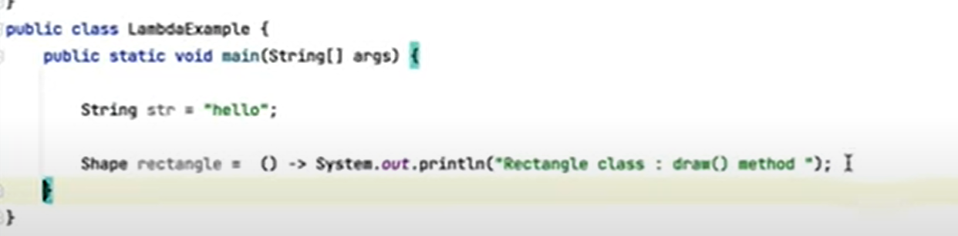

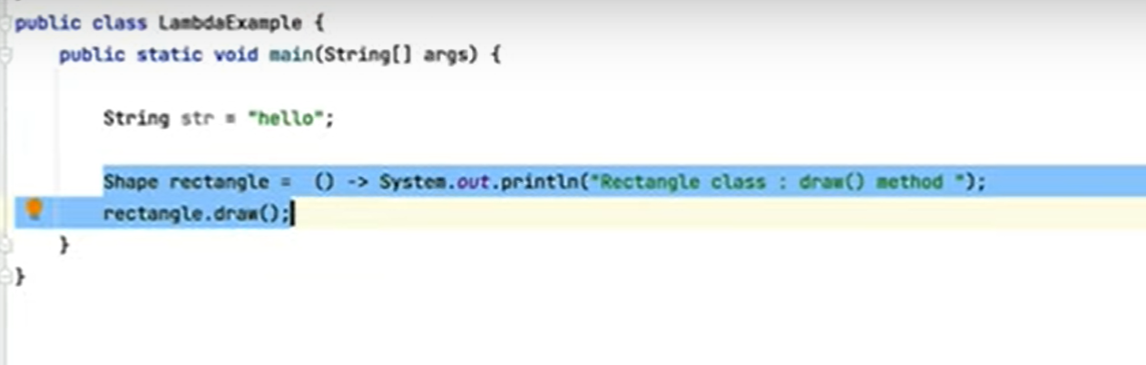

# Functional Interface

Functional interface contains exactly one Abstract method but n number of static and default methods

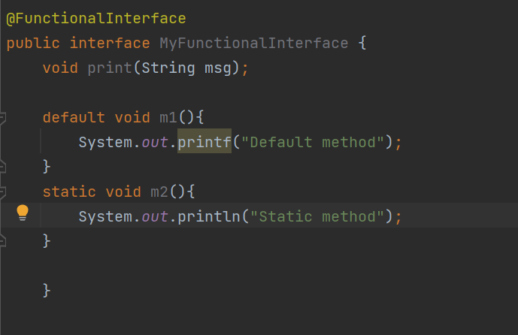

class FunctionImpl implements Function<String, Integer>{  
 @Override  
 public Integer apply(String s) {  
 return s.length();  
 }  
}  
  
public class FunctionalDemo {  
 public static void main(String[] args) {  
 //Traditional Method  
// Function<String, Integer> function = new FunctionImpl();  
// System.out.println(function.apply("Anusha"));  
 //Lambda Method 1 where there are multiple lines  
 Function<String, Integer> function = (String s) -> {  
 return s.length();  
 };  
 System.*out*.println(function.apply("Anusha"));  
  
 Function<String, Integer> function1 = (String s) -> s.length();  
 System.*out*.println(function1.apply("Anusha"));  
 }

Accepts a String input and returns the Integer value